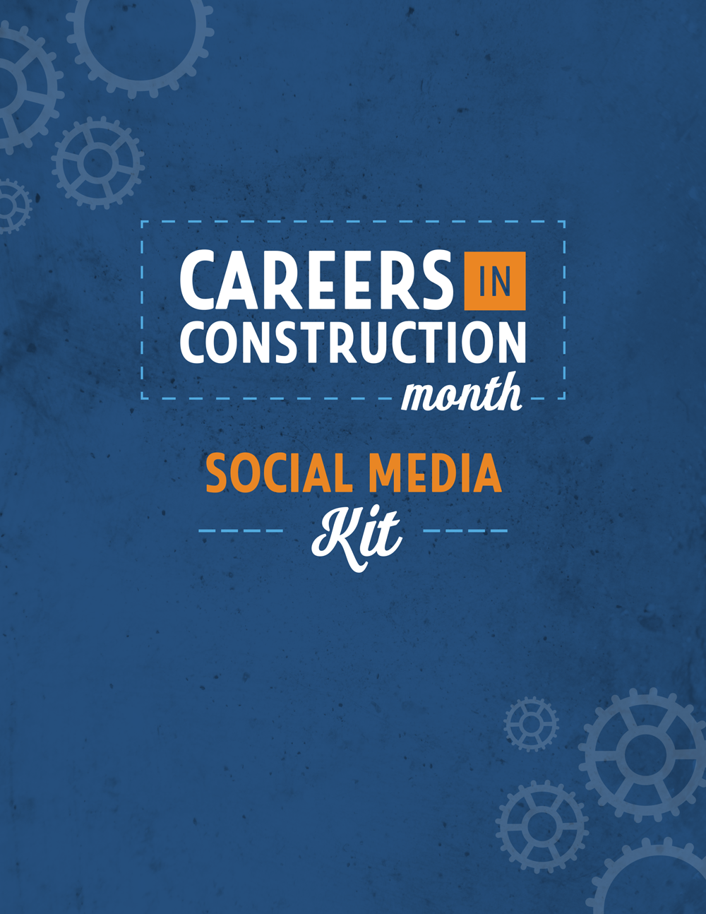

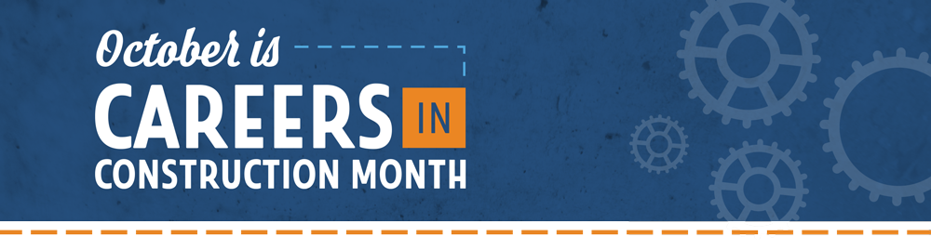

Careers in Construction Month is an annual month-long celebration of craft professionals and the career opportunities in the construction industry.
Every October, organizations around the country work together to raise awareness of the great careers in construction.
During #CICM, we highlight the skilled men and women who build America, provide information and resources for educators and industry representatives, and inspire the youth of today to choose a rewarding career as a craft professional.

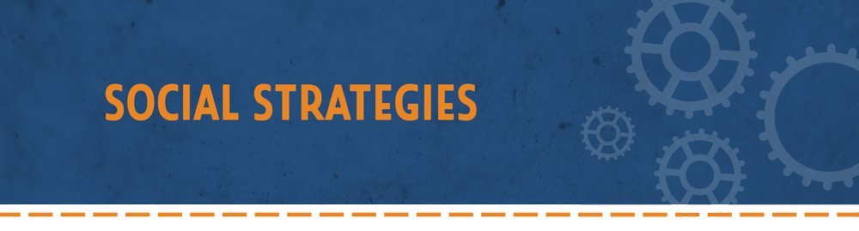

During October, the industry should use social media to promote construction careers.
- Use the hashtags #CICM and #CareersInConstruction in posts.
- Share posts, images, articles and videos about why construction is a great career path.
- Highlight successful craft professionals from your organization.
- Showcase different types of careers in construction and why current professionals enjoy their work.
- Explain to parents why their children should explore craft training.
- Describe how interested people can become a craft professional.

Key Messages:
- Construction is more than a job – it’s a career.
- Craft skills are in-demand nationwide.
- Careers in construction offer financial freedom through high salaries and affordable education options.
- The industry is safer thanks to improved tech, regulations and focus.
- A career as a craft professional is dignified and requires high skills.
- The industry is open and welcoming to everyone.

You can copy and paste these examples for posts on social media or create your own!

October is Careers in Construction Month! Join the industry all month long as we celebrate craft careers! #CICM #CareersInConstruction byf.org/cicm

Craft skills are in demand! Now’s the perfect time to explore a career in construction. #CICM http://www.byf.org/explore-careers/trading-cards/

Construction is more than a job – it’s a career! Learn more about life as a craft professional during Careers in Construction Month! #CICM

Our children have many roads to success. Learn more about careers with high demand, high salaries and high potential during Careers in Construction Month! discover.byf.org #CICM

There's never been a more exciting time to join the #construction industry! With a rising demand for craft professionals, a career in construction should be in the minds of every student. #CICM

Did you know that 7 out of 10 jobs don’t require a bachelor’s degree? #CareersInConstruction #CICM http://discover.byf.org/is-a-four-year-degree-always-the-right-choice-for-students/

1 million craft professionals, such as electricians and carpenters, will be needed by 2023. It’s time to promote #CareersInConstruction! #CICM

Share our pre-made CICM graphics on social media or create your own! Download at byf.org/resources.

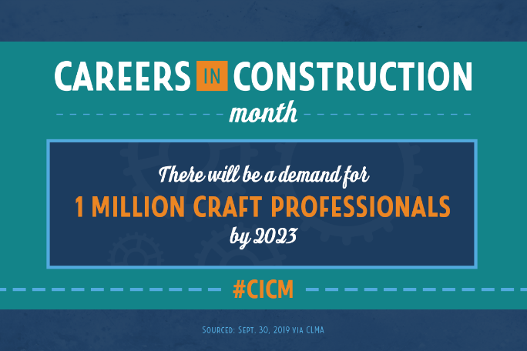
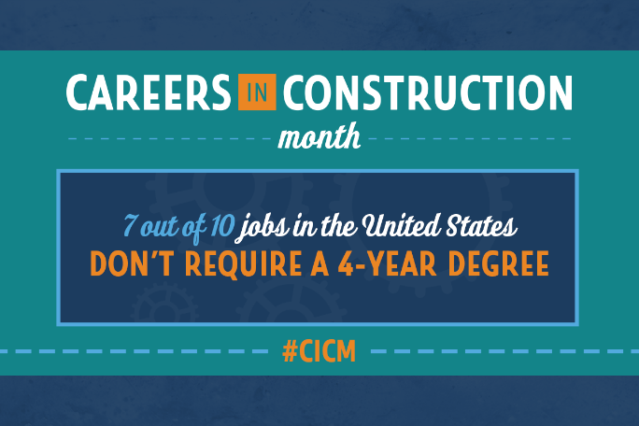

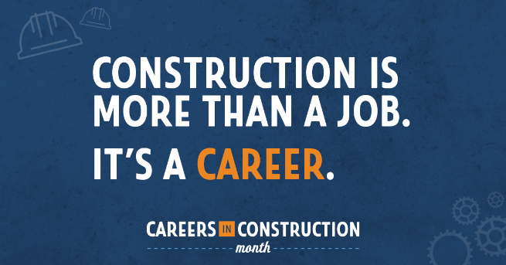
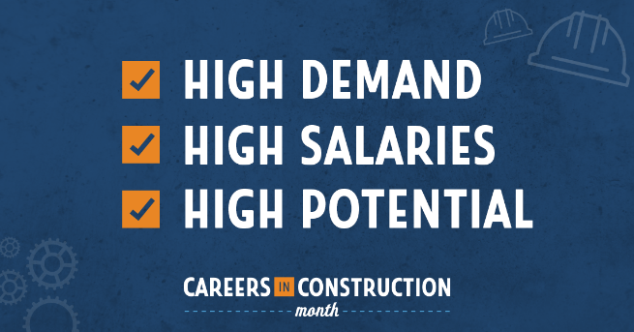

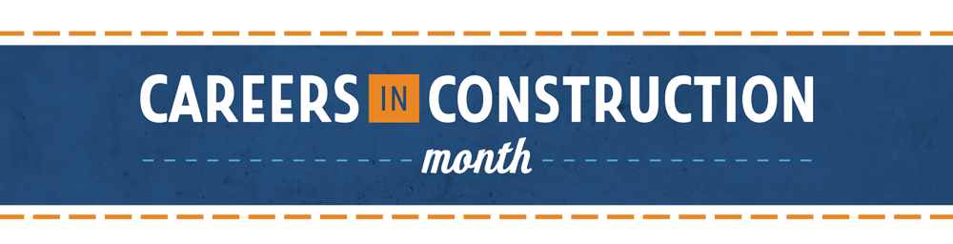
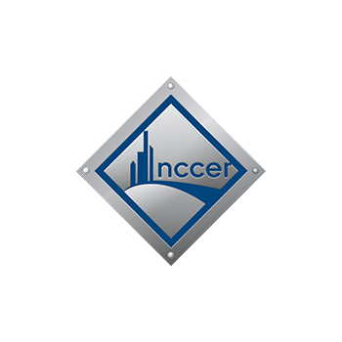

NCCER is a not-for-profit 501(c)(3) education foundation which offers training curricula, assessments and credentials for more than 70 crafts through over 6,000 NCCER-accredited facilities across the United States.
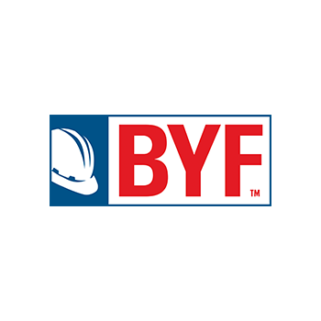

BUILD YOUR FUTURE is a recruitment initiative working to find the next generation of craft professionals and close the skills gap and labor shortage in the construction industry.

For more information,
email marketing@nccer.org or visit byf.org/cicm.

Copyright © 2019 by NCCER and Build Your Future.

The messages and images within this document may be redistributed in support of Careers in Construction Month.

