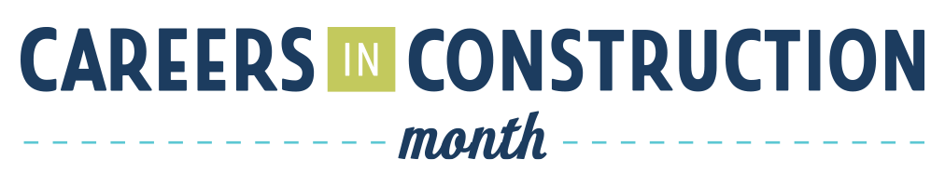

Proclamations Social Media Guide
To promote October as Careers in Construction Month (CICM) and generate support for the initiative, all organizations who file a request with their state to proclaim CICM are asked to share updates about their proclamation and CICM plans on social media.

Follow BYF
Hashtag
#CICM
Use on Twitter, Instagram, Facebook, LinkedIn and other social media channels when talking about Careers in Construction Month.

Follow Build Your Future on Social Media for
the latest updates and content about CICM.

Facebook: Build Your Future
Twitter: @BuildYourFuture
Instagram: @DiscoverBYF
YouTube: Build Your Future

Proclamation Graphics
Organizations who file proclamation requests and notify Build Your Future will receive special graphics that can then be shared on social media and your website.
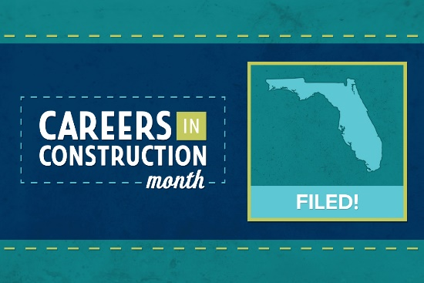

When a request has been submitted, organizations
will receive a light blue graphic that recognizes a
CICM request has been formally FILED.

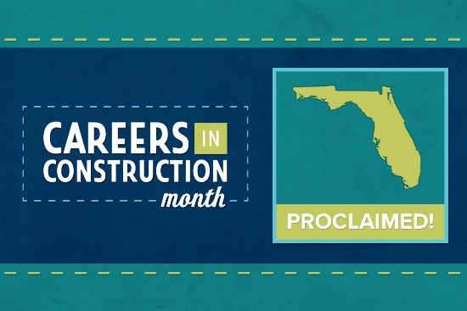

When a request has been approved and state government issues an official proclamation, the filing organization will receive an additional green graphic that shows your state has PROCLAIMED.
Below are some sample social media posts that you can copy and paste to include with your CICM proclamation graphics. Feel free to make your own captions as well! Remember to tag Build Your Future so we can share your post!

Sample Social Media Posts

Filed
  - We’ve filed a request for [Your State] to proclaim October as Careers in Construction Month! Learn more about #CICM from @BuildYourFuture: byf.org/CICM

  - October is Careers in Construction Month, and we’ve filed a proclamation request for [Your State] to make it official! #CICM

Proclaimed
  - [Your State] has officially proclaimed October as Careers in Construction Month! We’re excited to celebrate #CICM with @BuildYourFuture!

  - Our state is celebrating Careers in Construction Month this October – is yours? #CICM byf.org/CICM

  - October will officially be Careers in Construction Month in [Your State]! Join us and @BuildYourFuture as we try to bring #CICM to all U.S. states and territories! byf.org/CICM

Remember: In order to receive your graphics,
you must notify Build Your Future at proclaim@nccer.org.

CICM Map Updates
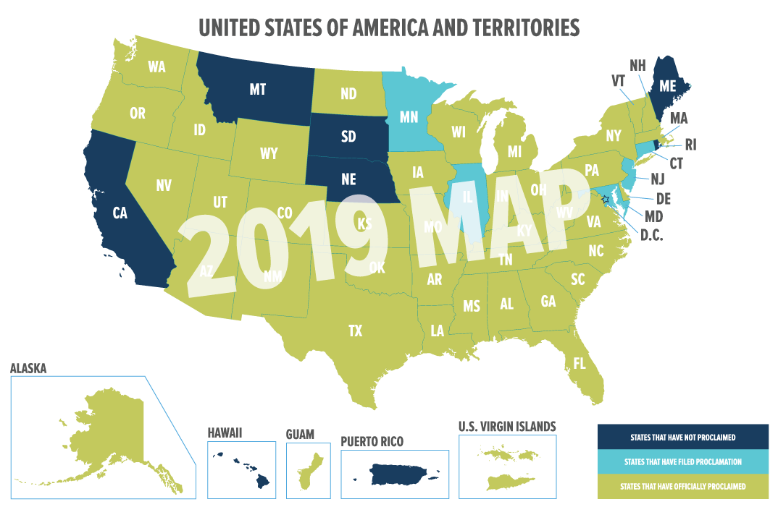
By updating us on your CICM request filings and proclamations, we will also be able to add your state to our color-coded Careers in Construction Month Map.
States in which no action has been taken will be dark blue. States where a proclamation request has been filed will be highlighted in light blue. States that have officially proclaimed will be labeled in green.
As new states file and proclaim, our map will be frequently updated and those updates will periodically be shared to social media by Build Your Future. You can share these map updates to show that your state is participating and encourage other states to join as well. Our goal is to get
Can we beat the CICM Map from 2019?
We need your help to do it!
participation from all 50 U.S. states
plus territories.

Official Proclamation Document
Once your CICM proclamation request has been approved, your state government should send you an official proclamation document signed by the governor.
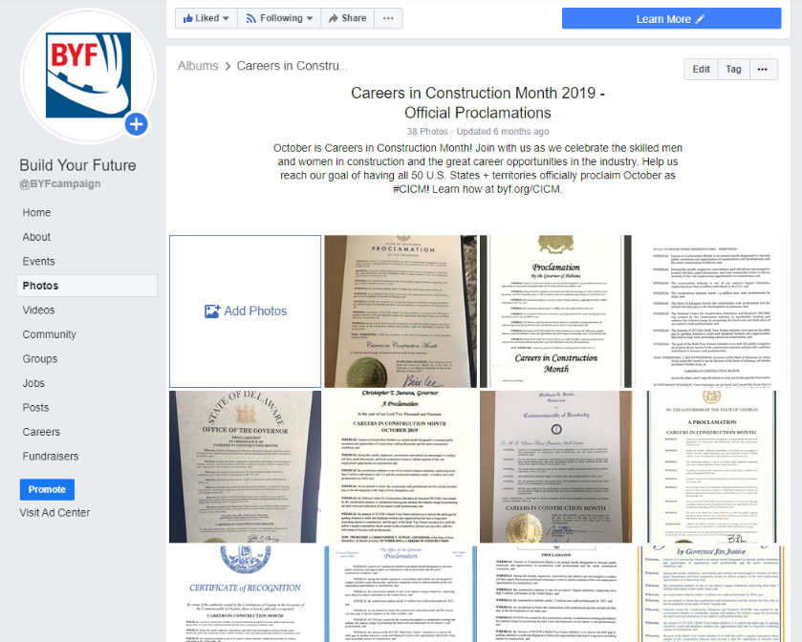
When you receive this document, scan a copy of it and submit it to BYF to notify us your state proclamation is official. In addition to updating our map and sending you your social media graphic, BYF will add your state’s proclamation document to our Facebook photo album for CICM 2020.
You can also share the document to your own social media. This is a great way to draw interest and support and adds validity to the month of celebration.
  - 2019 Official Proclamations Facebook Album
Other CICM Social Initiatives
As we approach October, keep an eye out for Build You Future’s Careers in Construction Month social media kit, which will include sample posts, downloadable graphics, and more great resources to help you celebrate CICM.
In the meantime, you can prepare your own content to share on social media before and during October to promote the career opportunities in the industry. Here are a few ideas:
- Blogs and articles
- Infographics and pictures
- Testimonials from real craft professionals
- Behind-the-scenes videos from the job site

Additional Resources:
- Careers in Construction Month Webpage at BYF.org
- Careers in Construction Month Handbook
- I Built This Construction Video Contest

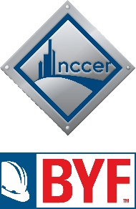
NCCER is a not-for-profit 501(c)(3) education foundation which offers training curricula, assessments and credentials for more than 70 crafts in over 6,000 NCCER-accredited facilities across the United States.
BUILD YOUR FUTURE is a recruitment initiative working to assist in developing the next generation of craft professionals, closing the skills gap and filling the labor shortage in the construction industry.

